Semester Project Proposal – HyShot II SCRAM jet analysis:

Project Selection

The hypersonic configuration chosen is the HyShot II SCRAM jet test vehicle launched by the University of Queensland Australia. This project was selected due to the large amount of articles available for this vehicle as well as the historical significance of the first flight tested SCRAM jet.

Objectives

The objectives for this project are to use the tools from this course to perform analysis of the inlet ramp conditions for the SCRAM jet in the experiment start value of 35 km at Mach number of 7.5. This will include the use of Newtonian and Modified-Newtonian surface inclination methods, real gas effects on the inlet ramp section, heat transfer to surface, and other relevant topics that are appropriate based on material covered and feasibility to complete additional analysis and discussion in the time permitted.

Outline

Begin by selecting component to be analyzed from the hypersonic vehicle configuration. This is selected to be the Intake plate, or inlet ramp.

Perform analysis relevant to current subject matter discussed in class.

* Relevant species concentrations and corresponding gas constants and specific heats
* Pressure distribution over the plate and side walls
* Heat transfer over plate and side fence
* Shock angles on intake plate
* Additional components possible, or fewer depending on time constraints and material covered

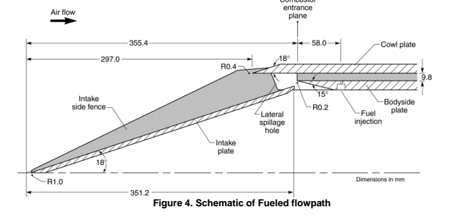

(Image from Flight Data Analysis of HyShot 2)

References

Anderson, John D., Jr. *Hypersonic and High Temperature Gas Dynamics*. N.p.: McGraw-Hill, 1989. Print.

Hass, Neal, Michael Smart, and Allan Paull. "Flight Data Analysis of the HYSHOT 2." *AIAA/CIRA 13th International Space Planes and Hypersonics Systems and Technologies Conference* (2005): n. pag. Web.

Pecnik, René, Vincent E. Terrapon, Frank Ham, Gianluca Iaccarino, and Heinz Pitsch. "Reynolds-Averaged Navier-Stokes Simulations of the HyShot II Scramjet." *AIAA Journal* 50.8 (2012): 1717-732. Web.

Cain, T., Owen, R., and Walton, C. “HYSHOT-2 Aerodynamics.” *Proceedings of the Fifth European Symposium on Aerothermodynamics for Space Vehicles (ESA SP-563). 8-11 November 2004, Cologne, Germany. Editor: D. Danesy., p.229.*

\*\*Many other Sources to be sited later in project. These sources were chosen to demonstrate that the Geometry and data to compare results against, both experimental and numerical, for this vehicle are overwhelming available.